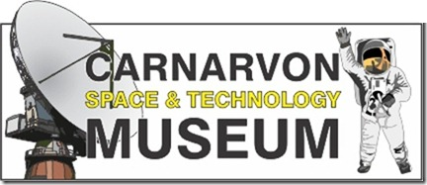
APPLICATION FOR MEMBERSHIP OF AN INCORPORATED ASSOCIATION – model rule 5
Carnarvon Space and Technology Museum Inc
Applicant Details:

Name……………………………………………………………………………………………………………….

Address……………………………………………………………………………………………………………

Phone………………………………………………………………………………………………………………

Email………………………………………………………………………………………………………………..
Membership Type (please tick): Single ($25 per year) Family ($40 per year)
** Membership due 1st November annually***

Family Member names: Adult 1: ………………………………………………… Adult 2: …………………………………………………

Child 1: ………………………………………… Child 2: …………………………………… Child 3: ……………………………………..
Declaration:
If my application is accepted, I agree to be bound by the rules of the Association.

Signature…………………………………………………. Date…………………………………

---------------------------------------------Applicants to detach and keep-------------------------------------------------

Please make membership payment to:
Carnarvon Space and Technology Museum
BSB: 066168
Account no: 10245347
State your “Name” and the word “Membership” in the description.

Membership applications will be presented at the next committee meeting after payment is received. If membership application is not successful, a full refund will be applied.

INFORMATION FOR APPLICANTS

- Your annual membership includes free entry to the museum, as many times per year as you wish, PLUS 15% discount on items you purchase in our shop, and 15% discount on museum special event tickets for events held in the current membership year.
- If your application is accepted, your name and address, as provided above, must be recorded in a register of members, and made available to other members upon request to the secretary under section 13(4) of the Carnarvon Space & Technology Museum Constitution.
- If the obligations under the Associations Incorporation Act are not complied with, the Association can be dissolved.
- Annual Membership fees: $25 per single, $40 per family (2 adults & 3 children)
- Membership does not commence until the membership fee is paid and the application is accepted at the next committee meeting.
- You can contact the Association at PO Box 194, Carnarvon, WA 6701, (08) 9941 9901 or email secretary@carnarvonmuseum.org.au
- You can access or correct personal information (your name and address) by contacting the association as indicated above.

OTHER INFORMATION

If the application for membership is rejected by the committee: under the association’s rule 6(7), committee will notify the applicant accordingly, and is not required to provide its reasons for rejecting the application.

A copy of the association’s constitution is available on the museum website.

